SIMATS ENGINEERING
ASSESSMENT TOOL1
COURSE CODE: MLA 0202 COURSE NAME: Fundamentals of Machine Learning
Name:Ch.B.Vinay Register Number:192425148
Faculty:M.S.Saravanan
COURSE OUTCOME COVERED
CO2: Apply supervised learning algorithms for regression, classification, and predictive modeling tasks to solve structured data problems in practical applications. (BL3)
Assessment Tool Weightage: 40%
QUESTIONS: 10 Total Marks:50 Annexure A
Analytical Problem Solving
Code of Conduct:
I Ch.B.Vinay(192425148) (Name / Reg No) certify that this submission is my original work and that I have adhered to the guidelines specified for this assessment.
I understand that any violation of academic integrity rules will result in disciplinary action. Signature of the student: Ch.B.Vinay

Annexure A
Analytical Problem Solving
Q1.House No Area (sq.ft) Bedrooms Price (₹ Lakhs)
1 1000 2 50
2 1500 3 75
3 800 2 40
4 1200 3 60
5 2000 4 90
(i) Construct a linear regression model of the form
(ii) Estimate the regression coefficients.
(iii) Interpret the meaning of each coefficient.
Code:
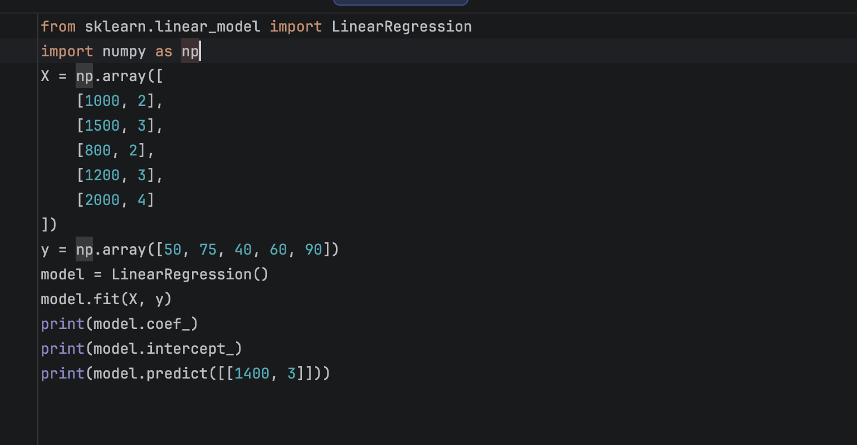
Output:
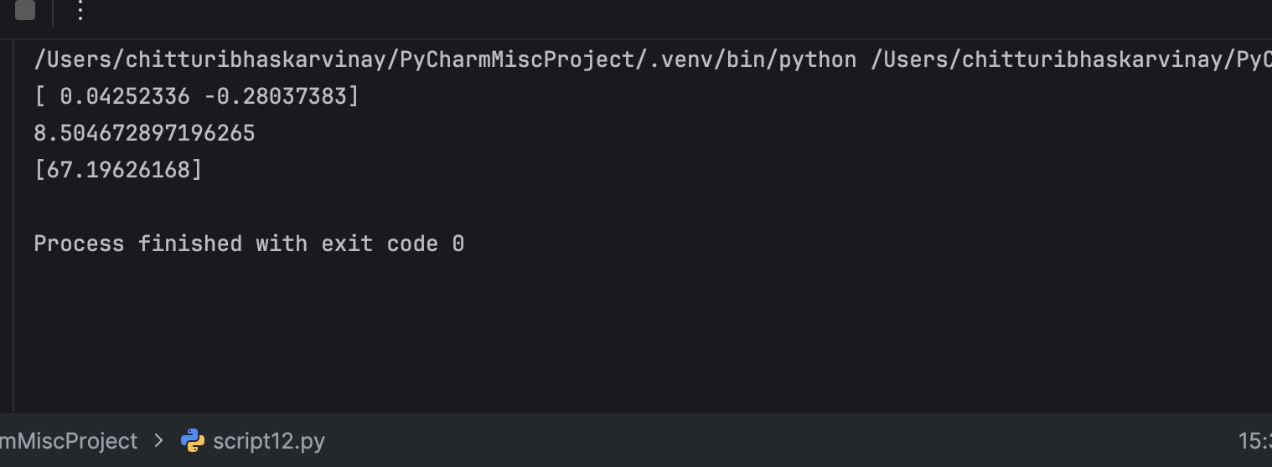
Q2.Email Word Frequency (Offer) Word Frequency (Win) Spam (1/0) 1 3 2 1
2 2 1 1
3 1 0 0
4 3 3 1
5 0 1 0
(i) Construct a linear classification model.
(ii) Determine the decision boundary.
(iii) Classify a new email with: Offer = 2, Win = 1.
Code:
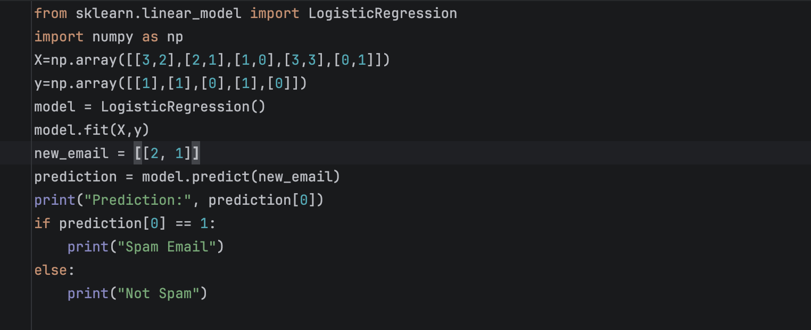
Output:
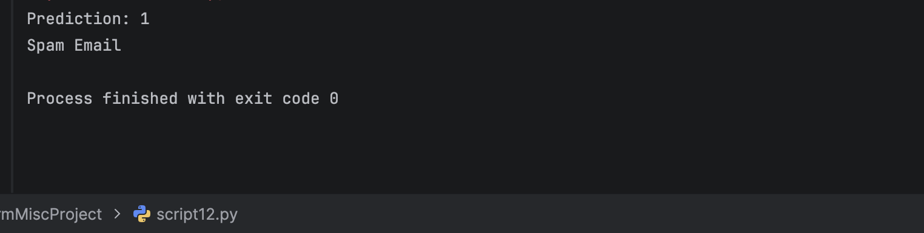
Q3. Patient Fever (1/0) Headache (1/0) Disease (Yes/No)
1 1 1 Yes
2 1 0 Yes
3 0 1 No
4 1 1 Yes
5 0 0 No
(i) Compute prior probabilities.
(ii) Compute conditional probabilities.
(iii) Estimate the probability that a patient with Fever = 1 and Headache = 0 has the disease.
Code:
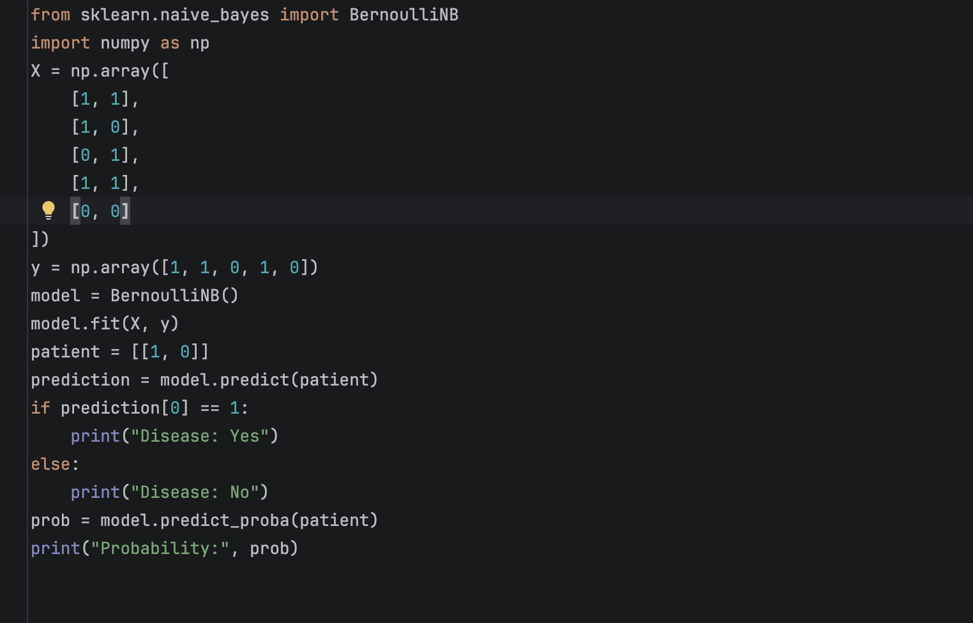
Output:
